# Python Flask Web Application

# Author: Bedemariam Degef

# Date; Mach 1, 2020

# My second web application

Figure 1 running the python web application within AWS Cloud9 IDE

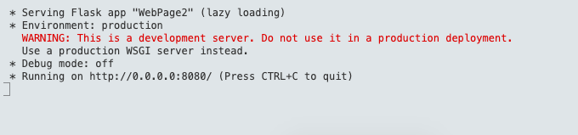

Figure 2 screen captures of web application running on the Browser with 5 images local on cloud9 IDE and

a table with 8 rows and 5 columns

Figure 3 screen captures of using the text area and a select drop down component

Figure 4 output file result on cloud9 IDE after submit button clicked

Figure 5 Reset button resets the two text fields

Figure 6 exiting the python web application

